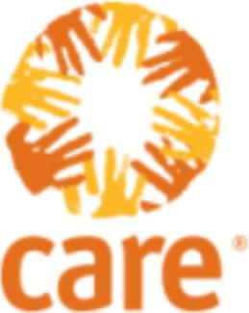
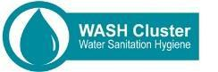

Making gender sensitive and inclusive programming simple and practical

Care International’s piloting of the
WASH minimum commitments for the
Safety and dignity of affected people

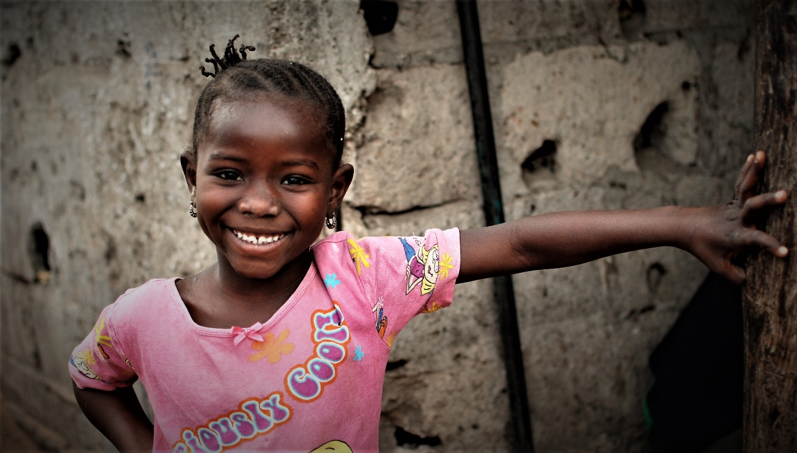

Taking stock of the minimum commitments implementation in Nepal, Niger and Vanuatu

April 2017

Executive summary:

The minimum commitments are a tool meant to make gender sensitive and inclusive programming tangible, simple and practical. They cover core actions or approaches which WASH sector members should systematically apply in their operational response at each phase of the project cycle.
First used by country clusters, they became a key resource for the global WASH cluster that developed, in 2014, minimum commitments for the safety and dignity of affected people. Care International has been involved from the start in the piloting of the tool. It is now working on widening its uptake and on ensuring a systematic roll out of the tool. The team first took stock of the pilot roll out of the commitments in 2015. This second report focuses on the experiences of the WASH country teams in Niger, Vanuatu and Nepal in using the tool.
The commitments were introduced in the three countries during a dedicated training. While results in Vanuatu and in Nepal have been really promising, the ownership of the WASH team in Niger has been more problematic, mainly due to staff turnover and to a lack of ongoing support in rolling out the approach.
The 5 commitments have been found useful by the country teams in the sense that it has widened the attention paid to diversity, with a reinforced consideration for certain groups whose specific needs were not always considered in the past. Before, the team was not sure how to integrate the different aspects of gender and vulnerability in WASH activities, or if it was addressing all aspects as required. The tool acts as a guide to ensure that it is taking care of all aspects. The team’s capacity has been enhanced.
While the commitments have been designed to be suitable for all crises-affected countries, it was found that each country places an emphasis on the commitments that are the most relevant to their context: In Niger, the tool has influenced how monitoring is done, with a focus on users’ satisfaction. In Nepal, attention is paid to access issues for persons with mobility issues and older persons. In Vanuatu, adolescent girls’ needs, especially around menstruation, have been central to the actions taken.
While good practices for the development of a gender sensitive and inclusive response existed before, the tool has helped improve the design of the facilities, with more attention to the needs of older people, persons with disability and adolescents. In Nepal, for instance, the team incorporates design accessible to persons with disabilities (ramp, wider space in the toilet), child friendly taps and a separation of public toilets. Female toilets in schools are now being designed with a provision of taps and bathing space inside the toilet to cater for the needs of menstruating girls. These efforts have led to a sharp decrease in the number of absenteeism’s in school attendance. The tool has also been helpful in becoming aware of the needs of transgender users.
The commitments have helped raise awareness on issues of safety, satisfaction, representation, participation and equitable access. Staff in Nepal and Vanuatu have increased consultation sessions with female community members to solicit their feedback on the WASH programme implementation and how best to incorporate everyone’s needs. The team ensures that their voice is heard in WASH Committees as active members. Issues such as participation are now deemed critical, being more robustly embedded in the needs assessments and the monitoring and evaluation of the projects.
In addition to helping improve the implementation of the response, the commitments led to a recognition that gender and vulnerability issues need to be “institutionalized” in the work of the organization. In Vanuatu and Nepal, the 5 commitments are integrated in the EPP, in the country level strategy and in the proposals. This has also influenced the recruitment approach and the appointment of gender focal points.
Care has ensured other stakeholders also apply the commitments, becoming a tool for the cluster or sector. In Nepal and Vanuatu particularly, it has influenced partners and authorities in their own project evaluation processes and in the way they design public facilities. In Vanuatu, Care is organizing a workshop that will gather different partners. This will be the occasion of presenting a case study as well as a short video, show casing success stories since the implementation of its WASH programme, informed by the 5 minimum commitments.

1-Why were the WASH minimum commitments developed?
Conflicts and natural disasters affect girls, boys, women and men differently. For example, the very young or very old may have difficulties in accessing facilities; adolescent girls and women collecting water may have to walk long distances unprotected, placing them at risk of attack or limiting their time for other tasks. In other words, affected people have distinct experiences and capacities to deal with crises and different views of what the WASH assistance should be like.
As humanitarian actors it is our role to understand these differences and deliver services and aid that assist all segments of the population, while placing no one at risk.
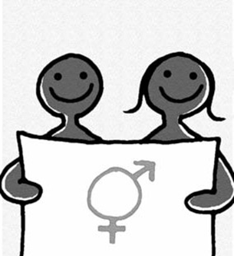
Simply providing WASH facilities does not guarantee they will adequately and effectively meet everyone’s needs. A participatory approach at all stages of a project is essential for a positive impact on public health. The response must be gender-, age-and diversity-sensitive, and involve women, girls, boys and men of different ages and backgrounds equally. This broad participation meets basic sanitation needs, prevents disease, and plays an important role in the protection and dignity of individuals, particularly girls and women.
Yet, in the rush of responding to the most urgent needs, insufficient analysis and attention is given to these issues. Lack of capacity on how to take gender, age and diversity issues into account, considered too complex, too abstract or too time consuming, needs to be addressed.
The minimum commitments are a tool meant to make gender sensitive and inclusive programming tangible, simple and practical. First used by country clusters, they became a key resource for the global WASH cluster that developed, in 2014, minimum commitments for the safety and dignity of affected people. Care International has been involved from the start in the piloting of the tool and is now working on widening its uptake.
The WASH commitments reflect key priority issues in the sector. They are grounded on a combined analysis of:
- The needs or barriers certain groups may face based on gender, age or diversity,
- An understanding of gender dynamics that may lead to vulnerabilities (e.g. expectations for girls to carry water-related tasks that may affect their capacity to access education and may place them at risk of violence)
- An analysis of existing challenges on the quality and appropriateness of the WASH assistance provided (what sector teams don’t do well), such as limited access and use of WASH services by all.
The commitments help place affected people at the very centre of the response, supporting a collective reflection on quality and inclusive programming with questions such as:
“How well do our needs assessments capture the distinct impact of the crisis on women, men, boys and girls of all ages?"
« The added value of this tool has been to meet the specific needs of all, including older people, persons with disability, adolescents, which was not necessarily the case before.”
WASH team, Care Nepal
“How consultative are we when planning, implementing, and monitoring our interventions? Is participation inclusive enough? “
“Do we give voice to groups at particular risk of violence or who might be unable to access WASH facilities, such as adolescent girls or persons with reduced mobility?”
“Are our WASH facilities and services of sufficient quality to meet dignity and safety needs?”
“How do we ensure our interventions are on track? Can women and men, the young and the old, equally provide feedback and place complaints?”
“What do we do well and less well? How do we deliver a safe and accessible response? How can setting minimum commitments help us collectively address these challenges?”

2-What are the WASH minimum commitments?
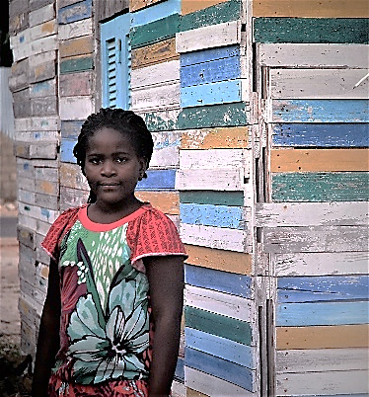
The minimum commitments cover core actions or approaches which WASH sector members should systematically apply in their operational response at each phase of the project cycle. They are practical, realistic and focus on improving the way the sector teams operate rather than on drastically reorienting programmes. The WASH commitments are clear about the value they add to current programming and the concrete actions needed to meet them. They are measurable for the follow-up and evaluation of their application as a questionnaire and traffic light system accompany their use.
The 5 commitments are as follows:
- Consult separately girls, boys, women, and men, including older people and those with disabilities, to ensure that WASH programs are designed so as to provide equitable access and reduce incidences of violence;
- Ensure that girls, boys, women, and men, including older people and those with disabilities have access to appropriate and safe WASH services;
- Ensure that girls, boys, women, and men, including older people and those with disabilities, have access to feedback & complaint mechanisms so that corrective actions can address their specific protection and assistance needs;
- Monitor and evaluate safe and equitable access and use of WASH services in WASH projects;
- Give priority to girls (particularly adolescents) and women’s participation in the consultation process.

3-What is this report about?

Care’s WASH sector is currently working on widening the uptake and enthusiasm in the minimum commitments and ensure a systematic roll out of the tool.
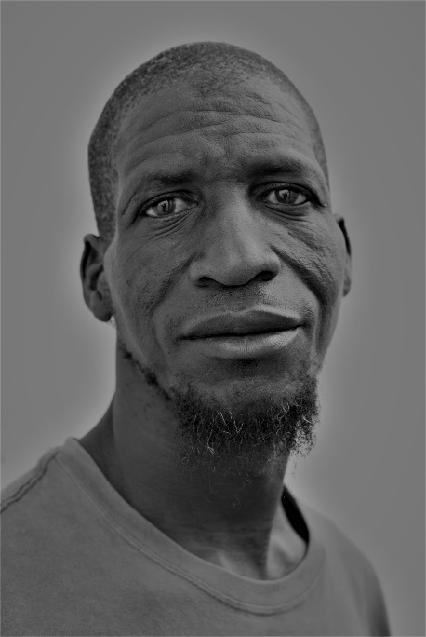
Understanding what have been the benefits and limitations of the tool in pilot countries has been considered an essential step to improve Care’s approach, to address challenges and to build on successes.
The team first took stock of the pilot roll out of the commitments in 2015. This second report focuses on the experiences of the WASH country teams in Niger, Vanuatu and Nepal in using the tool.
Specifically, the report looks at:
- How the commitments were first introduced;
- How the commitments have been making a difference in the response being provided to affected people (e.g. consultation, location and design of facilities);
- How it has helped build capacities and has influenced teams’ perception of how gender, age and disability can be integrated in the response;
- How it has helped initiate a dialogue and build a shared vision on what inclusive WASH programming is about;
- How it has influenced the strategies, response plans, funding requests, staff recruitment and M&E of the sector;
- How it has had a broader reach than Care’s WASH team, being promoted and adopted by the WASH cluster and local government authorities;
- What have been the challenges in rolling out the tool, what are the identified limitations of the commitments and what is recommended in order to imporve them;
- What additional support country teams would require in order to ensure that affected people keep being placed at the very center of Care’s WASH interventions.
4-Nepal’s roll out of the WASH minimum commitments

Interview with Urmila Simkhada and Pandey Nilkantha (WASH engineer), Care Nepal, 23d of February 2017
- How were the commitments introduced in the WASH program?
It was introduced through the training held in 2015 that targeted Care and the partners.
- Is the team still using the commitments? If this is not the case, why is this so?
Yes, it is a key tool.
    - Did the commitments influence the practice/delivery of the sector (e.g. the way consultations are done, design of WASH facilities, increased attention to certain groups, increased focus on issues such as access or protection?)
There were good practices existing before, such as the distribution of female hygiene kits. The commitments have yet made a real difference in how WASH programs are implemented. The 5 commitments were useful in the sense that:
-It has helped systematize attention to gender, age and diversity at the different phases of the project cycle
- It has widened the attention paid to diversity, with a reinforced consideration for certain groups whose specific needs were not always considered in the past. The added value of the tool has been to meet the specific needs of all, including older people, persons with disability, adolescents, which was not necessarily the case before.
The team has ensured the commitments were followed at all steps of the project. In practice:
-The team has ensured that women, men, adolescent girls and boys participate at all the stages of the HPC.
-They ensured that, at a minimum, 33% of women were represented in committees, in line with the government requirements.
-The commitments have influenced the design of the facilities. The team incorporated design accessible to PwD (ramp, wider space in the toilet), child friendly taps, separation of public toilets allowing to manage menstrual hygiene needs. This was not systematically done before.
-In rural areas, the team helped women produce locally made pads. Staff consulted the women and girls about the use and relevance of the kits.
- The team has developed education materials in local language that are in line with the 5 commitments.
The beneficiaries asked Care to use the same practice in other locations.
- Has the tool influenced the team’s own capacities and perception of how gender, age and disability can be integrated in the response? If so, in what way?
“The 5 commitments have helped systematize our good practices, it has reinforced the inclusiveness of our projects”.
“The impact of the 5 commitments is to make WASH accessible to all”

The commitments were helpful in becoming aware of the needs of transgender users. Before the team had not paid attention to them. Staff was only thinking of females and males. It is still a big taboo. Care in Nepal is still working on translating this into the design of the facilities.
- Has the introduction of the commitments helped build a shared vision and a dialogue among the team of what quality, inclusive WASH programming is about? If not, why?
The team is now aware of the importance of meeting the needs of all because of the training. It is a serious issue.
- Have the commitments been integrated in the CO’s WASH strategy, response plan, gender action plan, training, proposals, staff recruitment, etc?
- The 5 commitments are integrated in the EPP, in the country level strategy.
- It has influenced the recruitment policy. The job descriptions include an element on how to implement WASH programs that are more inclusive. This is not only related to the 5 commitments but also to Care’s commitment to gender equality.
- The team has appointed a gender focal point. The 5 commitments are part of her tasks and reporting responsibilities.
- The commitments are considered in the proposals.

- Is the tool used for self-assessment, M&E purposes (e.g. use of the traffic light system as a monitoring tool to determine where the difficulties lay and to identify corrective actions, use of the commitments to guide your monitoring of projects during field visits, etc)? If not, why?
« The commitments really influenced other partners and authorities that have expressed appreciation of the tool and that will include it in their own project evaluation processes. “

The team does not use the traffic light system but has the practice of collecting information by sex, age, diversity groups. The team uses the commitments as a target. While doing the baseline and evaluation, staff asks about satisfaction, about ways of increasing participation, feelings of safety, GBV. Before, it did not include these questions in monitoring. It developed indicators. This allows Care to see if it meets its target.
The team will include elements of the 5 commitments in needs assessment. It would like to assess how the 5 commitments help decrease violence.
    - Does the team promote the tool with other partners, for instance among members of the WASH cluster?
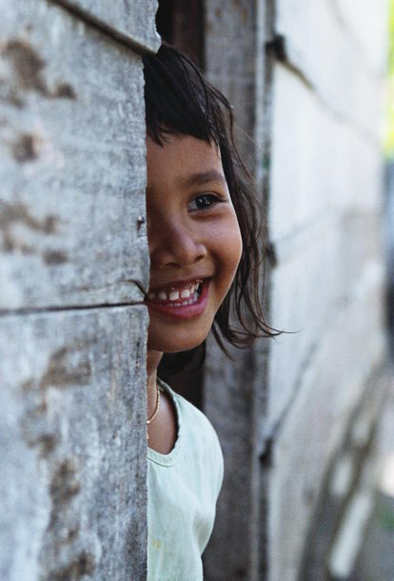
Care has presented the commitments to the district WASH authorities so that they replicate the tool in their own programming. The implementation of the commitments supports the WASH authorities’ approach, as their policy is in line with the 5 commitments.
The team is ensuring that other stakeholders also apply the commitments. For instance, it made sure other partners would implement them, such as with the construction of separate toilets in health centres when before they were mixed.
The tool really influenced other partners and authorities that have expressed appreciation of the tool and that will be included in their own project evaluation processes.
    - What are the recommendations to improve the tool and to better roll it out?
A possible improvement would be to include the commitments in the job description.
The 5 commitments capture the most important points and are suitable to the Nepalese context.
Attention to transgender people could be strengthened.
As the team saw the added value of the tool, it recommends that it is rolled out in other countries.
    - Are there elements the team would like to get support on?
It doesn’t need anything at this stage.

5-Niger’s roll out of the WASH minimum commitments

Interview with Sani ELH. DAN AOUDE, CARE Niger, Quality & MEAL Officer, Humanitarian Coordination, 17th and 21st of February 2017

- How were the commitments introduced in the WASH program?
In 2015, selected team members and other cluster partners participated in a training on the commitments, that served as a reminder of the mandate of Care on gender equality. The country office is applying some of the commitments but, for those who were not part of the training, they apply them without relating their practice to the tool. The staff having not followed the training uses other gender tools from Care. New staff is not aware of the 5 commitments as this is not part of the briefings being provided. The capacity of the team on gender-related issues needs to be reinforced. The training was instrumental in mobilizing the team on the commitments.
- Is the team still using the commitments? If this is not the case, why is this so?
The commitments are still somehow used but there is a need to refresh knowledge, particularly among the implementing team.
- Has the tool has influenced the team’s capacities and perception of how gender, age and disability can be integrated in the response? If so, in what way?
This is difficult to say
    - Did the commitments influence the practice/delivery of the WASH response (e.g. the way consultations are done, design of WASH facilities, increased attention to certain groups, increased focus on issues such as access or protection?)
The CO has done 3 needs assessments that include gender issues.
Consultations are broken down by sex and age (women, men, young girls, young boys), which was the case before but the commitments made it a standard practice. The cultural context does not allow going much further in terms of breaking down the consultations by age and diversity, especially when it comes to consulting young women.
The difficulty the team faces is that the preferences expressed by users during the consultations sometimes go against technical good practices.
There is now more attention to the design of facilities that are accessible to persons with disabilities. This is more due to the training received on the tool than to the 5 commitments as such.
The tool influenced how proposals are developed, especially regarding what is monitored. Before, the indicators were not specific. The indicators are disaggregated by sex and age and look at the level of satisfaction and distinct level of access.
In terms of the emergency coordination within Care (emergency coordinator, team leaders), there is more attention paid to gender issues, taking into account the 5 commitments. This is visible in their involvement when developing proposals and in the instructions on how users should be consulted and facilities designed. It is yet difficult to say if this is linked to previous exposure to gender issues or if this relates to a clear consideration of the 5 commitments.
    - Has the introduction of the commitments helped build a shared vision and a dialogue among the team of what quality, inclusive WASH programming is about? If not, why?
The team has understood something new: Before hygiene kits were distributed to women with no attention to the needs of children. Now diapers are provided. Yet, it is difficult to link this to the 5 commitments, to the training on the 5 commitments or to the gender and diversity training organized on a different occasion.
“There is now more attention to the design of facilities that are accessible to persons with disabilities. This is more due to the training received on the tool than to the commitments as such. “

- Have the commitments been integrated in the CO’s WASH strategy, response plan, gender action plan, training, proposals, staff recruitment, etc?
The 5 commitments are not included in the WASH strategy. The strategy includes indicators in line with the 5 commitments but this is not directly derived from the tool.
- Is the tool used for self-assessment, M&E purposes (e.g. use of the traffic light system as a monitoring tool to determine where the difficulties lay and to identify corrective actions, use of the commitments to guide your monitoring of projects during field visits, etc)? If not, why?
No, this is not used.
    - Does the team promote the tool with other partners, for instance among members of the WASH cluster?
No. It is also not clear if the partners of the WASH cluster use the commitments.
    - What are the recommendations to improve the tool and to better roll it out?
The commitments are very clear. Yet, the message is the same as the guidance provided in Care’s tools. The commitments follow the same principle and, from this perspective, it is difficult to say what sets this tool apart, except for the fact that commitments are concise, which is a positive aspect.
    - Are there elements the team would like to get support on?
A refresher training for the team would be much welcomed. There is a need to reinforce the understanding and the capacity of the WASH team on this matter.

6-Vanuatu’s roll out of the WASH minimum commitments

Interview with Julian Tung – WASH Programme Manager and Andrew Koda – WASH Team Leader, CARE Vanuatu – Tanna Field Office, 28th February 2017

- How were the commitments introduced in the WASH program?
The first time the Minimum Commitments were introduced in Vanuatu was in March 2016 in a training workshop that brought together not only CARE Staff but other agencies as well, for example ADRA, Red Cross, NDMO (National Disaster Management Office) etc. During this training an overall action plan was developed with key milestones identified. A second workshop was held later in the year with the help of a consultant to review what had been achieved at that moment and to further consolidate learning, strengthen the integration of different sections of the WASH programme as well as other related programmes like Gender and Women Empowerment and the resilience programme.
“Before the commitments were introduced, the team was not sure how to integrate the different aspects of gender and vulnerability in WASH activities, or if it was addressing all aspects as required. But now the tool acts as a guide to ensure that it is taking care of all aspects.”
- Are the commitments still being used? If this is not the case, why is this so?
Yes, the minimum commitments have become the backbone of the WASH programme and indeed all the programmes being undertaken by the Tanna Field Office. It is being used as the approach for an integrated programme with close support from the Gender and Programme Quality Section.

    - Did the commitments influence the practice/delivery of the WASH response (e.g. the way consultations are done, design of WASH facilities, increased attention to certain groups, increased focus on issues such as access or protection?)
This tool has provided the team with the approach to ensure that it takes everything into consideration especially all aspects of gender, vulnerability and social inclusion (gender, age and diversity) right from needs assessment, design, to implementation, the way staff conducts feedback and consultations with the community members to programme monitoring and strategy frameworks.
All proposals are now formulated with the minimum commitments in focus, which was not being practiced before. The WASH programme strategy has also been reformulated to include the 5 minimum commitments. To give examples:
- The design of toilets has now been done to give a focus to those living with disabilities. In each of our target schools, there is now a provision of a toilet accessible by those with physical disabilities (ramp, more space inside the toilet; rails for support, etc.)
- Staff is now holding regular consultation sessions with girls in primary and secondary schools to seek their views regarding their needs and how best to address these
- Girls’ toilets are now being designed with a provision for taps and bathing space inside the toilet to cater for the needs of menstruating girls
- The PHAST teams jointly with the GESI teams are holding joint MHM activities. They have agreed on MHM kits as suggested by women and girls (for example reusable kits; underwear of different sizes and colour, etc) as well as on the targeting criteria for the neediest girls in schools. These efforts have led to a sharp decrease in the number of absenteeism’s in school attendance
- Staff increased consultation sessions with female community members to solicit their feedback on the WASH Programme implementation and how best to incorporate everyone’s needs
- The team ensures that their voice is heard in WASH Committees as active committee members
- The monitoring framework has also been reformulated to include specific indicators on women and girls as well as on issues of accessibility by all in terms of age and vulnerability.
“The Minimum commitments are incorporated in proposal development. As a result, the programme is receiving more funding”

- Has the tool influenced the team’s capacities and perception of how gender, age and disability can be integrated in the response? If so, in what way?
This tool was new to most of the WASH staff. Before the commitments were introduced, the team was not sure how to integrate the different aspects of gender and vulnerability in WASH activities, or if it was addressing all aspects as required. But now the tool acts as a guide to ensure that it is taking care of all aspects. Its capacity has been enhanced.

- Has the introduction of the commitments helped build a shared vision and a dialogue among the team of what quality, inclusive WASH programming is about? If not, why?
Since the introduction of the minimum commitments, it became evidently clear that the teams must plan and work together. Hence, the WASH strategy was updated as an integrated team effort that has now shaped the future of the WASH programme. In this respect, joint planning is also done with other sectors using the minimum commitments as a guide. The team now holds regular mid-term review exercises to check on progress and take stock of achievements.

- Have the commitments been integrated in the CO’s WASH strategy, response plan, gender action plan, training, proposals, staff recruitment, etc?
The Minimum Commitments are now part of the Country’s WASH Strategy as a shared vision which is reflected upon periodically during mid-term reviews.
The MEAL Framework and indicators have also been updated to reflect the Commitments.
The Minimum commitments are incorporated in proposal development and, as a result, the programme is receiving more funding.
When recruiting staff, the programme is now taking gender balance considerations in forming and defining team requirements. For example, if there is a vacancy which is advertised and there are no female applicants, Care is now proactively engaging volunteers whom it trains on the job. If they later qualify for the post, they are given first consideration. For example, a female member from the poll of volunteers was recently recruited to join the technical team.

- Is the tool used for self-assessment, M&E purposes (e.g. use of the traffic light system as a monitoring tool to determine where the difficulties lay and to identify corrective actions, use of the commitments to guide your monitoring of projects during field visits, etc)? If not, why?
When conducting monitoring activities during field visits, the team has designed questions for focus group discussions with women, girls and men separately; key informant interviews with different leaders. These questions are formulated bearing in mind the minimum commitments checklists like level of satisfaction, accessibility of WASH facilities for different vulnerable groups like the elderly, the people with disabilities etc.
The team is now incorporating different feedback and complaints mechanisms through the guidance of the minimum commitments. For example, it is reaching out to female members in communities to have focus group discussions regarding their perceptions on the progress of the programme activity, their satisfaction and where they think more needs to be done or problems require to be addressed. It is currently testing the use of mobile phone to solicit feedback and receive complaints from beneficiaries.

It is reaching out to girls to have separate discussions with them regarding their MHM needs and through their feedback, it is designing facilities that cater for their needs.
The minimum commitments have also helped improve data collection and reporting mechanisms. Data is now being segregated by sex and age, something that was not happening before. The team now understands the benefits of having sex and age disaggregated data.

    - Is the tool promoted with other partners, for instance among members of the WASH cluster?
From the beginning, the minimum commitments were introduced in a workshop that brought together many implementing agencies within Tanna. It has therefore been easy to share experiences and lessons learnt amongst different organisations.
« In the past, teenage girls missed a week of school each month when they had their periods. Today, thanks to the Minimum Commitments, simple redesign of school toilets is changing a long-standing problem in Vanuatu's schools »
The WASH programme is now organising an important workshop on gender and WASH in April where staff plans to share its experiences and lessons learnt with a bigger audience. The workshop will be held in Port Vila, the capital of Vanuatu and will bring together different agencies already engaged in using the minimum commitments, but also others who would be interested in learning about them and being involved. To prepare for this, the team is developing a case study as well as a short video, show casing success stories since the implementation of its WASH programme, informed by the 5 minimum commitments.

Are there recommendations about how the tool could be improved or better rolled out?
For now Care Vanuatu is still gathering its lessons learnt. The outcomes of the workshop will determine if the team needs any further support and in what form.

- Are there elements the team would like to get support on?
For now, everything seems to be going well.

