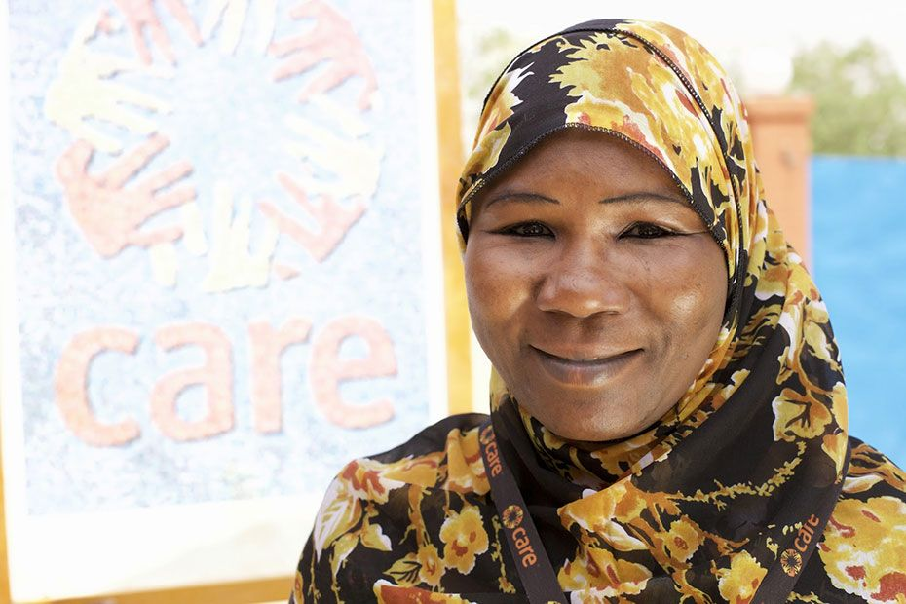
SHADO: Gender in Emergencies
Lessons Learned
October 2017
Author
Greg Jack – CARE International
www.care-international.org

Acknowledgements
This paper has benefitted from the valuable contributions of CARE International colleagues, especially Kathleen O’Brien, Isadora Quay, Siobhan Foran and Emmanuel Lan Chun Yang.
The views in this paper are those of the author alone and do not necessarily represent those of the CARE or its programs, or the Government/any other partners.
Cover page photo: Gender in Emergencies Advisor Fatouma Zara Laouan
Image: Frederic Courbert

SHADO - Lessons Learned
SHADO was a highly innovative pilot project to advance gender in emergencies learning. We wanted to find ways to increase the number of skilled staff who would be available to deploy as gender in emergencies (GiE) advisors to a humanitarian crisis. Other agencies apart from CARE were involved, and it was funded by the START network. This report shares what we learned from the project.

Deployments:
People were not available to deploy. Out of the 10 participants who completed the course, only two made deployments. A third was interested but had to cancel the deployment at the last moment due to pressing work in their own office. Whatever the reasons for this, this is a huge lesson. We cannot assume that staff with other jobs and responsibilities will be available to deploy. In this project we provided a lot of support to deployments – finding appropriate opportunities, giving training, covering deployment costs, ensuring a mentor – and still the level of interest was low. We will do a quick online survey to try and find out their reasons.
We tested assumptions that proved to be incorrect. We thought people would be really interested in deploying. There are other cohort approaches starting up with the same basic assumption. We think it is likely to be a flawed assumption. This is CRITICALLY important for CARE and the sector. Perhaps the barriers are too big. Whatever the reasons why (and there are many), the end result is critical. We cannot take it for granted that staff will be available.
Find out about barriers to deploying early on. We would recommend to do this at the selection process – to add a question about whether the person foresees any barriers to them deploying.
Contingency planning helped. The team showed incredible flexibility for finding alternative models. We knew that this may be an issue and put plans into place for different eventualities – encouraging deployments, doing additional marketing work on the possibility, trying different deployment models (shadowing, stand-alone deployment with remote support). This helped us to get the results that we did.
Another model is possible. At present, we recommend looking at alternative models where GiE Advisors would be deployed into an explicitly mentoring role, with training still provided to counterparts through a similar approach to this one. This would allow counterparts to “shadow” directly in their own country, as well as receive specific skills-building (rather than a learning by osmosis approach that can work well or be entirely unsuccessful). This does not rule out an interagency approach and might be a powerful way to affect the way that multiple agencies are working.
Three very different approaches gave a range of different experiences to learn from. It was a richer set to examine than would otherwise have been available. It did make it trickier to draw conclusions about the impact of the shadow deployments, as we had more variables that contributed to the results in each case.
Training helped identify “stars” – but we had to stay flexible. We identified one clear star from the training. We felt comfortable deploying her on her own, and we could add her to the roster straight away after. She was someone who had just left an agency when we accepted her on the program and so didn’t fit all the acceptance criteria. Staying with the spirit of the program, and not trapping ourselves in rules. The training gave good insights into the high skill level she had, so the risk of deploying her with remote support (as a trial) was low.
“Shadowing” was not clearly defined. We never clarified exactly what the role of the shadow should be. How much should they be observing how the expert performs their tasks, how much should they be trying to do the same tasks as the expert, and how much should they be assisting the expert (but doing different tasks to them)? This would vary between deployments, of course. But it needs more discussion and agreement to determine what we expect from the shadows. This must be communicated to them and to the experts they are shadowing.
The approach of mentoring in the persons own country gave many benefits. They were able to contribute more. They could provide insights on context and quickly provided insights on what works what doesn’t. Recommendations were better targeted, more relevant, and identified existing good practices to scale up. An outside expert by themselves may have needed more time to find these. The downside is that it is very hard for that person to step out of their regular role and focus on learning. They easily become overstretched or otherwise unavailable. It is vital to plan for this if we try to use this modality in future.
One of the major pluses for the shadowing approach to learning was that experts could provide concrete coaching. An example from the Uganda deployment was being able to give quick guidance on preserving client confidentiality. These are small aspects of how someone is doing their tasks. It’s difficult to get to this level of detail in classroom training. It has big impacts on the quality of the work done and the level of professionalism. Shadowing and mentoring helps in improving the daily work of the shadow.

Virtual Training
Using an expert virtual learning consultant gave great results. They were able to assess our situation and goals extremely clearly and made high-quality, innovative recommendations that shaped the training component. The report was widely shared in CARE and the experience has greatly increased our appreciation of the possibilities of online learning. This is potentially revolutionary for CARE and has already ignited several other work streams.
The approach used for the training is highly replicable but content would differ. It can be run for other sectors or topics using a similar framework.
Despite a very short timeframe the simulation materials, assignments and background documents were all very high quality. In addition to the materials themselves, the consultant working on these did a great job of determining the best time to send them and structuring the feedback criteria and process. We were very happy with what the participants actually received and the learning experience.
Due to the very short development times, we lacked a clear overview in advance of the course of the times, dates and level of effort that participants would need to make at different points in the course. We weren’t able to do a good enough job of setting expectations about time constraints and time allocations and dates in advance. Some participants reported being double-booked during simulation days, with other meetings scheduled. Some of the responsibility to negotiate around clashes is theirs, and some was due to that lack of clarity. We now have that overview and can communicate much earlier in the future.
The course completion rate was lower than hoped, and still very respectable for online learning (where very low rates are the norm). We could have used a greater variety of approaches to draw people in to the course and maintain engagement. Short videos or quick readings could have helped.
Running the course through email was inefficient. Assignments were sent through email, as was all communication. Emails could have been clearer and more structured – they were largely sent as “emails” rather than designed parts of the training. With greater advance planning we could also have used automatic (timed) sending of emails to make it smoother and more predictable, and have obtained an appropriate email alias for course communications in advance.
However, we really loved that the course was delivered using a platform that was familiar to participants. Sending assignments through email mimicked their regular working environment, enhancing realism and recall. This reduced the mental load on them and allowed them to get on with the task we wanted them to focus on, rather than on navigating a learning system.
The mentoring component needs a significant rethink. It was planned for all participants to have access to a peer support group, with a mentor from the GiE team assigned to each. The idea was that the mentors would have a strong active role in the course, both supporting the groups in informal sessions, and undertaking some assignment review. Neither really worked. The mentors didn’t receive much support in their role, just a WebEx call to explain the idea and what was being asked of them. Mentor deployments and course drop-outs meant that some mentoring groups soon became unworkable and fell apart. The mentoring element of the course needs reworking to build on these experiences and to find a more practical way of doing it. If we maintain the mentoring element, mentors need a clearer timetable (which should be fine), training on working virtually, a longer lead in time and access to mentoring resources (such as from CARE’s Catalyst program). Mentors could play an important role in increasing completion rates. This would require a lot of work from the mentor and from the course team to support the mentors. The mentors we selected were mainly those who deploy full time. We can’t plan for them to be available on an ongoing basis – deploying will always have to take precedence.
Feedback was both difficult and extremely helpful. With the number of mentors available dropping, the work of providing feedback on assignments fell on members of the course team (Gender Advisor and consultant trainer). This was a huge extra (unplanned) workload. Feedback was highly appreciated by the participants and critical for them to receive. In the future we should find ways to allow for (meaningful) peer feedback, or other approaches that reduce the amount of marking that any single individual does.
Comparable assignments gave us confidence in learning. Participants completed similar assignments in the first and second simulations. The quality of their assignments improved. As these assignments mimicked real job tasks, we are confident that they were getting better at their jobs. The structure of the course made that possible – and made us happy that they had a basic level of skills to use on deployment.
Participants valued the training. They gave it extremely positive evaluations, both for the course methods and for their learning. For example, 60% of the respondents said the course enabled them to confidently use new skills on the job. 90% said that they were confident they could use their new skills on the job. 70% said they would make using their new skills a high priority in their job. These results show good quality training that supports participants transferring what they learned to their jobs. Combined with the improvement in assignment scores (measuring the quality of realistic job tasks) we can conclude that the training had a strongly positive impact.
Despite some internal discussion, the decision to focus on technical skills was the right one. Those doing deployments could improve their soft skills under the tutelage of an expert. Technical skills are a necessary starting point for adding value in a deployment. We might look at ways to train people on soft skills in future iterations. That should not be at the expense of the strong focus on technical skills. The training focused on technical work, but also emphasised prioritization and communication, important soft skills.

Selection
Key pieces of information were not absorbed by the participants (and their offices). These included: time was needed to work on assignments and attend training sessions; back-up for deployment; that deployments did not cover salaries, etc. Whilst this information was stated twice and we required participants to state they had approval, a lesson is that we needed other approaches to communicating it, and to get a confirmation of sign-up from managers.
The diversity of inter-agency participants gave us a good variety of people on the course. Many had a lot to add to the training program.
There seemed to be a discrepancy between what people said in their application and their actual skills. In particular there seemed to be a problem with responses about the length of time working on gender and the formal study on gender. Without a common base of skills, it was hard for participants to complete the training tasks, and for trainers to guide them through. The number of people potentially available for deployment was also deceptive (as some people clearly would not have been able to leave their ‘day jobs’). A pre-screening interview or test would have been overkill for a program like this. Our lesson here was that (with more time) it would have been better to use a nomination process. Networks of contacts can get higher-quality applications. We should keep a process to accept them, to avoid unsuitable participants.
There were also relatively few applications compared to the number we could accept. A larger number of applications would have given us a few more qualified applicants to choose from. It would have allowed us to reject some of the less ideal participants that we did decide to take.
The team was designing the program at the same time that applications were ongoing. This meant that there was an inevitable lack of clarity in our communications to potential participants. We were unable to specify a start date for training, specify a duration and level of effort, specify who would be eligible for deployment, and when, etc. This made it hard for participants to plan their participation to get the most from the program.

Set-up
Due to the type of funding, there was no scope to add additional staff to work on the SHADO project. For the project team it was added to an existing full set of commitments. Work was not taken off the project teams loads in order for them to allocate time to the project. Without the time set aside for the project, aspects were often rushed and it was done “on the fly” as a labour of love by a small, passionate group.
The initial vision of the project had been for more traditional face-to-face training for the participants. During set up we changed this to explore virtual training. This was somewhat easier to outsource, and managing the course design and logistics for a face-to-face course also felt challenging. It also gave us the chance to test highly replicable approaches for virtual training.
One of the team members left CARE after helping with the concept phase of the pilot. Another took parental leave during the set-up period. The four key CARE staff on the team are based in four different countries and three very different time zones. Together with other staff deploying, this led to gaps during the hiring process. This was aggravated because as a pilot, not all team members were clear on (or had fully agreed) to the ToRs for the Virtual Learning and the Gender in Emergencies consultant(s). Team members had different ideas about the roles of the consultants, what they would do, etc. At some points, there were situations where the team was trying to coordinate decisions, which became a bit messy.
Partnering gave us less flexibility in some aspects. When we needed to use an extension to create more deployments, the partner’s resource wasn’t available after a certain date, and the learning piece had to conclude by then. It was a good idea to have a partner at arm’s length for the learning study. This gave them more credibility as an observer. The reality was that they struggled to grasp the intentions of the program and how it worked. The final report was OK, but their lack of understanding of the concept hampered both the process and the end result. Separating “learning” from “doing” made it hard for them to understand the challenges and the concepts.

CARE International Secretariat
cisecretariat@careinternational.org
www.care-international.org
Geneva Office
Ch. De Balexert 7-9
1219 Chatelaine (Geneva)
Switzerland
Phone: +41 22 795 10 20
Fax: +41 22 795 10 29

About CARE
CARE International is a global confederation of 14 member and 4 affiliate organisations working together to end poverty.
In 2016, CARE worked in 94 countries around the world, implementing 962 poverty-fighting development and humanitarian aid projects, to reach more than 80 million people directly and 256 million people indirectly .

