Ways forward for implementing the CARE 2020 Program Strategy

For the first time in CARE’s seventy years of history, we have an organization-wide program strategy, which describes the changes in the world we want to see and CARE’s role in bringing about those changes. The strategy was approved by the CARE International Board of Directors in June 2014 and its purpose is to focus our programs to clarify – both internally and externally – how we will contribute to eliminating poverty and social injustice.
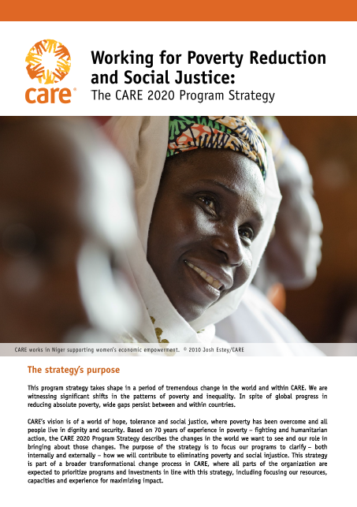
The strategy is part of a the transformational change process at CARE, where all parts of the organization are expected to prioritize programs and investments in line with the strategy, including focusing our resources, capacities and experience for maximizing impact. Across CARE, there is great momentum and inspiration for implementing the strategy. This is an opportunity to unite and galvanize around a clear purpose. It is also critical for maintaining CARE’s relevance in a rapidly changing context to which international NGOs need to adapt.
The strategy is a short, high-level document and it is therefore critical to propose a clear way forward for implementing it. This document identifies priority actions across CARE for implementing the strategy and working interdependently towards its outcomes. A few important points about this document:
- You will see that the implementation plan is short and simple. This is on purpose: it is important to start with what we must do right-away for implementing the strategy and develop more detail over time. We have identified actions we can carry out immediately for operationalizing the strategy and others which will have to be fleshed out over time. The implementation plan will be a ‘living document’.

- All of CARE has a role to play in implementing the program strategy. The strategy has implications for strategic planning, program design, presence reviews, fundraising, and many other processes. Rather than developing a ‘mega plan’, this document aims at highlighting when and how we need to act consistently with the strategy.

- The plan provides an overall, global perspective of critical actions for implementing the CARE 2020 Program Strategy and is intended to connect across CARE. However, it will be critical to develop more specific plans, relevant to each context, for CARE’s programs, Country Offices and Members. Please do share your thoughts, perspectives, ideas from your particular context and thereby contribute to better connect across CARE, as well as to develop more specific plans for the strategy to come to life.

- The process of implementing the strategy should foster inclusive decision-making and action at CARE. Rather than ‘policing’ alignment with the strategy, it is critical to inspire interdependent ways of working. Teams across CARE are developing innovations for implementing the program strategy. This document is an open invitation to share, connect and engage.
This implementation plan has been developed based on the inputs of many colleagues across CARE and facilitated by the Program Team. It contains three main sections: a) what success looks like, b) elements of the implementation plan and key actions, and c) opportunities for, and obstacles to, advancing the strategy. At the end of this plan, you will find a summary of actions for FY15 and FY16. All feedback, ideas and suggestions welcomed! Please remember that we will continue shaping this plan as we make progress toward the CARE 2020 Program Strategy.

- What success looks like

What does success look like? How will we know whether we are making progress toward the CARE 2020 Program Strategy? These are critical questions which we will have to keep asking as we implement the strategy.
The Program Team did some initial brainstorming of how we envision success year by year, from July 2014 to June 2020. This ‘picturing’ is not intended to provide a full panorama of what success will look like, but rather show the areas where change is expected in light of the program strategy. These areas are leadership, alignment and accountability, programs and impact, CARE’s presence and legitimacy, and fundraising and communications. While the overall picture of how to advance the strategy is critical (progress to which we all need to contribute!), it will also be useful to reflect about the specific changes required in your particular context in line with the strategy.
Year 1  By June 2015 | Leadership, alignment and accountability  - There is strong commitment, motivation and enthusiasm for the strategy across CARE. Staff and members of Boards know our common program purpose and use the strategy as a lens for decision-making.  - CI Members provide reports for the June 2015 Board meeting (and meetings thereafter) on their successes and challenges in aligning with the strategy.  - CI Program Team and Program Directors establish a mechanism for sharing key initiatives, to help link those who have common interests, to improve alignment and interdependence, and reduce overlap and duplication. It builds on existing processes, with a strong emphasis on direct contact with program teams and staff.  - CARE entities have pledged specific support for delivering the strategy. An analysis of costs has been carried out so that future resourcing can be planned.  Programs and impact  - It is clear what world class expertise in priority areas means. A tangible picture emerges about CARE’s innovation and added value.  - There is clarity on linkages between the outcomes, roles and the CARE approach of the program strategy. It is clear to all staff that the approach is essential for addressing the structural causes of poverty (gender inequality, poor governance and vulnerability).  - The Humanitarian and Emergency Strategy and Advocacy Strategy have been revised in the light of the program strategy.  - The impact report on SRMH provides evidence about CARE’s strong contribution to this outcome and learning for strengthening SRMH humanitarian and long-term development programs, advocacy and how to address gender inequality and violence through SRMH programs.  - The ‘multiplying impact’ role is better defined and we have clarity on the ways CARE multiplies impact, as well as plans on how to strengthen this critical role at all levels.  - Each outcome area has clear leadership and a strategy in place for advancing toward its target. The strategies show how we will implement the roles, the CARE approach and work with partners for reaching the outcomes. Impact indicators for each outcome area are clearly defined.
Continued from previous page  Year 1  By June 2015 | - Teams are in place for advancing the CARE approaches of gender equality and women’s empowerment, inclusive governance and resilience.  - Programs and projects have been mapped against the program strategy through the PIIRS annual survey; a baseline has been established. Staff has online access to project and participant data.  CARE’s presence and legitimacy  - Presence reviews include an analysis of alignment and potential contribution to the program strategy.  - Dialogue about CARE’s presence in the Global South/new membership is carried out through the perspective of the program strategy, as well as an assessment of CARE’s roles in the Global North in the light of the strategy.  - There is clarity of what ‘CARE presence’ means in a given context (ability to influence, innovate, amplifying the voice of people living in poverty, inspiring others rather than focus on ‘having an office’).  Fundraising and communications  - Communications for external audiences and messages by leadership reinforce commitment to the CARE-wide program strategy.  - The Fundraising and Branding Committee (F&B Committee) produces a refreshed brand narrative and guidelines to reflect the program strategy with CARE’s key donors, partners and supporters.  - Two-page briefs for outcome areas have been developed as an aid for fundraising and communications. Briefs make a clear reference to the roles and approaches.  - The four outcome areas have designated fundraising and communication leads, responsible for producing a resourcing strategy for each of them, with clear targets, as well as communications. Fundraising leads develop donor engagement plans.
Year 2  By June 2016  Continued from previous page  Year 2  By June 2016 | Leadership, alignment and accountability  - CI Member National Board Program Committees hold management accountable for implementing the relevant elements of the program strategy, for aligning existing resources with the strategy, and for mobilizing program resources (restricted and unrestricted) for its implementation.  - CI Members invest in core capacities for delivering on the 4 outcomes, the CARE approach (strengthening gender equality and women’s voice, promoting inclusive governance, and increasing resilience) and the prioritized roles (humanitarian action, promoting lasting change and innovative solutions, and multiplying impact).  - A clear accountability framework is developed by the Program Team, and agreed to by the Program and Operations Committee (POC), for holding all parts of CARE accountable for implementing the program strategy (indicators of alignment for budgets, programs and annual objectives).  - CARE teams use the program strategy as their starting point for program design, fundraising priorities, advocacy, communications, and investment rationale.  - All CARE entities include the strategy as an essential component of the orientation process for new CARE staff.  - Peer reviews are used as an opportunity to increase interdependence.  - All CARE entities have mechanisms in place for securing accountability toward impact groups and other stakeholders.  - Teams and leadership reward and celebrate alignment and successes at all levels.  Programs and impact  - The impact report on humanitarian programs provides evidence about CARE’s solid contribution with a strong gender focus, and is used for advocacy purposes.  - Plans for delivering on the four outcomes are ‘up and running’ with clear leadership and interdependent work across CARE. Effective communities of practice for each outcome have been established and are functional. Guidance for using the three roles and the CARE approach is in place.  - Results of the yearly PIIRS survey show a % increase in alignment to the strategy.  - Clear monitoring, evaluation and impact measurement guidance is developed and shared across CARE, both for long term programs and projects.  - New proposals, programs and projects are devised around the roles, approaches and outcomes of the strategy. Priority impact indicators are embedded in all.  - The Advocacy and Media Committee (AMC) has led the development of a campaign around one of the outcomes and launched it globally.  - There is significant, well-documented progress in playing the ‘multiplying impact’ role through local and national advocacy, global advocacy, scale up and other ways.  - A unified knowledge management and learning system, building on PIIRS, has been designed and a clear way forward agreed to for strengthening KM&L at CARE. The system is simple and ensures access to knowledge and learning about successful and evidence-based innovations at CARE, thereby increasing our ability to multiply impact.  CARE’s presence and legitimacy  - Decisions by the CI Board about presence are consistent with implementation of the program strategy.  - CARE has stronger, strategic partnerships at all levels (local, regional, global), as well as clear guidance for engaging with civil society. Significant attention has been paid across CARE to advancing partnerships at all levels.  - All of CARE’s main partners are familiar with the strategy. They view CARE as an organization fighting the injustice of poverty and focusing on rights, particularly those of women and girls.  - There is greater connection between countries for advancing joint regional initiatives, as well as global ones, on key cross-border issues around the program strategy.  - The role of CI Members from the Global North role has greater focus on addressing policies that contribute to the injustice of poverty in their contexts.  Fundraising and communications  - Together with other key messages, the 70th anniversary of CARE’s founding is used as an opportunity to profile our common program strategy.  - CI Members specifically include the program strategy as an element of annual reports and messaging to donors and supporters.  - CI Members implement new funding and cost recovery plans to grow resourcing for implementing the program strategy and reaching its outcomes.  - Resource development staff knows how to ‘sell’ the strategy and how to incorporate consistent program strategy language into all proposals.  - CI Members are investing in the growth of unrestricted funds and focusing their restricted funding efforts on resourcing the strategy.
Year 3  By June 2017  Continued from previous page  Year 3  By June 2017 | Leadership, alignment and accountability  - Bi-annual reports by CI Members and the Program Team for CI Board Meeting show progress in actions for advancing the strategy.  - Dynamic and good collaboration and clarity of roles between the CI Board, the Program and Operations Committee, the CI Program Team and other CARE entities is securing successful alignment and accountability.  - Specific accountability mechanisms/methodology is in place for obtaining potential complaints from stakeholders regarding CARE’s programs.  Programs and impact  - CARE is a valued partner in alliances and networks working toward humanitarian, SRMH/GBV, FNS and resilience to climate change, and women’s economic empowerment targets.  - CARE has increased its profile on global advocacy together with strategic partners and is an important player on gender equality and women’s rights. CARE has increased its ability to multiply its impact and its profile in global advocacy.  - CARE has a strong reputation for its focus on upholding principles of gender equality in emergencies and disaster risk reduction and is regarded as one of the top 5 organizations in this area.  - The impact report on food and nutrition security and resilience to climate change provides evidence about CARE’s strong contribution, and is used for advocacy.  - Impact reports have a strong reputation for their quality, illustrating our impact by using roles and approaches.  - The knowledge management and learning system is functional and central for multiplying impact through advocacy, scale up and other strategies.  CARE’s presence and legitimacy  - There is strong evidence of CARE’s increased legitimacy in the Global South by working more closely with partners and increasing the number of CI Members from the Global South.  - CARE’s presence in the Global North is aligned with the program strategy, emphasizing the ‘multiplying impact’ role (e.g. advocacy, private sector engagement, support from the public for campaigns, etc.).  Fundraising and communications  - Funding and resourcing plans start to generate additional resources for implementing the program strategy (both restricted and unrestricted).  - New fundraising pilots in the Global South have given us a solid model for investment and growth.  - Engagement with CARE’s supporter base results not only in increased funding, but also in support for concrete actions, advocacy and commitment to fighting poverty and inequality.  - Communications are focused on CARE’s impact; evidence from programs is used for donor and supporter engagement.
Year 4  By June 2018 | Leadership, alignment and accountability  - By having communicated clearly what CARE is about, we are held accountable by others for aligning with the strategy (through clear processes and systems).  Programs and impact  - Evidence of impact at greater scale in the four outcome areas (through implementing the roles and the CARE approach) is solidly emerging through impact and PIIRS reports.  - The impact report on women’s economic empowerment provides evidence about CARE’s strong contribution in this area, and is used for advocacy.  CARE’s presence and legitimacy  - CARE has strengthened the influence of voices from the Global South in its governance (in line with the Delhi Resolution).  Fundraising and communications  - There is a significant increase in unrestricted and restricted funds.  - Communications teams develop products to raise the profile of CARE’s impact and new models.  - CARE is recognized by key partners, donors and supporters for its program impact, in particular on women and girls, with an increased profile and reputation.

Year 5  By June 2019 | Leadership, alignment and accountability  - 90% of all financial resources in the CARE system are aligned with the program strategy.  - A review of progress toward CARE 2020 and a process to elaborate the next program strategy is under way, a process informed by the lessons learned and impacts achieved through the current program strategy.  Programs and impact  - Progress toward the outcome areas is regarded as successful by partners, impact groups and other stakeholders, and CARE’s contribution is highly valued, in particular because of our focus on rights and justice, and on the structural causes of poverty.  - CARE maintains its status as one of the top 5 organizations for emergency response and disaster risk reduction, with a focus on women and girls.  CARE’s presence and legitimacy  - In line with the Delhi Resolution, the majority of CI Members are from the Global South.  Fundraising and communicating  - CARE has increased its overall income by X% and its income of unrestricted resources by X%.  - CARE has significantly grown its regular supporters and achieved a greater proportion of its overall income from private sources.
Year 6  By June 2020 | Leadership, alignment and accountability  - The program strategy is consistently used as a lens for decision-making by all CARE staff and Boards.  - A new strategy is approved in June 2020 by the CARE International Board, based on learning and impact from the program strategy by this date.  Programs and impact  - Outcomes of the program strategy have been achieved and are celebrated across CARE and its partners.  - Learning from implementing the strategy has been captured for the next program strategy cycle.  - Strong interdependent work is modus operandi at CARE – a truly connected organization across humanitarian and long-term development programs, both in the Global South and Global North.  CARE’s presence and legitimacy  - CI Members from the Global South influence key decisions at CARE, critical for maintaining relevance in a fast-changing world for a global player like CARE.  Resourcing, fundraising and communicating  - Success of CARE’s strategy is amply communicated, attracting new donors and supporters, and maintaining the trust and support of ‘traditional’ donors.

- Elements of the implementation plan and key actions

Based on initial dialogue and reflections with several teams across CARE, we have identified nine key elements for advancing the implementation of the CARE 2020 Program Strategy, which are shown in the graph. For each of these elements, colleagues have suggested actions we must take right-away for aligning with the strategy. These immediate actions are critical to bring the strategy to life. We have also identified steps that will need to be fleshed out and deepened over time. Immediate actions are for FY15 as well as for the first semester of FY16 and are also listed, for easier overview, at the end of this document.
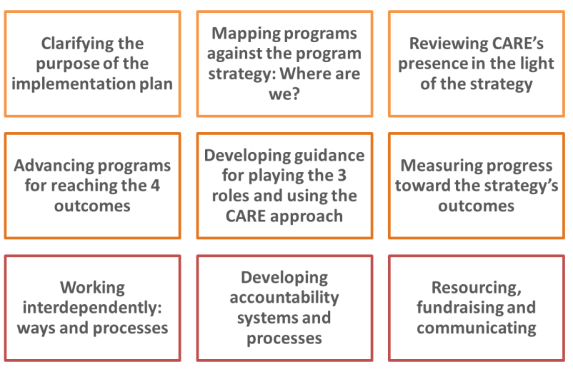
Please note that the actions listed below identify teams that will facilitate/lead a certain process. However, and as mentioned in the introductory section of this implementation plan, it is critical to engage teams working on specific programs in all regions, Country Office leadership teams and CI Members, and to develop context-specific response. In the spirit of fostering inclusion, we welcome your feedback about the concrete areas in which your team would like to actively engage.

Clarifying the purpose of the implementation plan

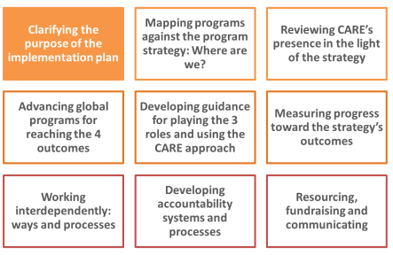
One of the main purposes of the implementation plan is to secure strong ownership and commitment to the CARE 2020 Program Strategy across CARE. It is to provide a clear way forward about how to implement the strategy. The plan intends to deepen our interdependence through guiding all parts of CARE to act consistently with the strategy and apply financial and human resources to support agreed program priorities.

The plan aims to highlight areas where change is needed for advancing toward the strategy’s aspirations. It builds on the many years of CARE’s experience with implementing program approaches and aims to foster incentives toward quality programming that makes a difference and has significant impact.

Actions we must take right-away
- Share this document with your team and solicit inputs and ideas for advancing the program strategy. What else can we do for working interdependently toward the strategy’s outcomes, approaches and roles? What other elements should we consider for the strategy’s implementation plan? All teams
- Review the plan and decide what your team’s main contribution for the strategy’s success will be. Which are the innovations, programs and processes that can contribute to advancing the strategy? All teams

Actions requiring further thought/fleshing out
- Refine the implementation plan over time. Include milestones and timeframes. Program Team to lead/facilitate based on inputs from teams across CARE
- Revisit the plan every six months and adjust according to progress and areas needing attention. Send your ideas and inputs for adjustment to the Program Team programteam@careinternational.org. All teams, Program Team to adjust the plan periodically
- Scan the environment to be sure that the strategy and its implementation plan maintain relevance in the evolving context in which we work. Program Team to lead/facilitate based on inputs from teams across CARE

Mapping programs against the Program Strategy – where are we?

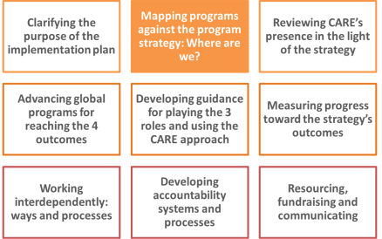
The information collected and disseminated by PIIRS allows mapping CARE’s programs against the program strategy. Yearly information tracks progress. It is important to note that this information allows mapping programs, yet it is also critical to assess the ‘organizational landscape’ and analyze ‘where we are’ in aligning to the strategy across CARE entities. Section C of this document kick-starts this dialogue about organizational factors.

Actions we must take right-away
- Participate in April/May 2015 calls for using the PIIRS online system and provide comments on how to improve PIIRS to fully capture key data. Program Directors and teams
- Develop checklist for program designs for assessing alignment with the strategy. Program Team
- Discuss PIIRS findings (and any other assessments carried out) with teams and agree on actions for strengthening alignment and progress toward program strategy outcomes, approaches and roles. Country Directors, Program Directors and teams
- Lead/facilitate dialogues about opportunities, as well as organizational obstacles, for aligning to the strategy. Where is your team? Agree on measures for strengthening alignment and contribution to strategy. National Directors, Country Directors and Program Directors

Actions requiring further thought/fleshing out
- Use data from PIIRS for bringing together colleagues working on outcome areas, approaches and roles. Foster dialogue and connection. Program Team and Program Directors
- Further reflect about which programs are fully aligned, partly aligned (and may have the potential to contribute), and which programs require significant change. Program Directors and teams

Reviewing CARE’s presence in the light of the CARE 2020 Program Strategy

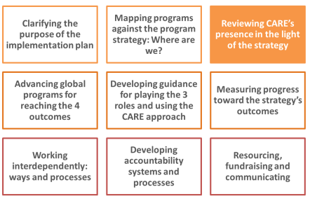
Reviewing CARE’s presence in the light of the program strategy is critical. The strategy proposes roles for different types of contexts as well as criteria for CARE’s presence in Middle Income Countries (MICs). To date, several presence reviews have been carried out in the absence of the strategy. It is important to reflect on the long-term presence that is required for delivering the strategy. In which countries does CARE need to be to achieve the outcomes? Does our lack of presence in certain contexts affect our ability to achieve our strategy? How do changes in the type of presence affect CARE’s humanitarian mandate? What may be some partnership models of emergency response?

Focusing on our program impact provides an opportunity – an exciting one! – to assess alternative models of CARE presence. Presence is not ‘having a director, staff and an office’. Presence is much more vibrant: it is related to our ability to influence, join in with others, gather more resources for the purpose of fighting poverty and inequality, and amplifying the voice of people and groups that lead/innovate/have passion for the fight against poverty and inequality. Presence means supporting genuine initiatives, rooted in the contexts in which we work. It means inspiring others and having clarity about what we need to deliver in each country and globally.

Actions we must take right-away
- Assess (without ‘redoing’) presence reviews carried out to date in the absence of the program strategy. What simple adjustments (if any) could be done for better aligning the proposed way forward with the strategy? Country and sub-regional teams who have completed presence reviews
- Revise guidance for presence reviews in the light of the program strategy and the Delhi Resolution. Program and Operations Committee (POC)
- Include at least one colleague from another country representing the Global South in steering committee of presence review. Teams leading upcoming reviews

Actions requiring further thought/fleshing out
- Carry out an analysis of presence in the light of the roles proposed in the strategy. Include countries and regions in which CARE currently has no presence. Do some ‘blue sky’ analysis of presence. Where do we need to be for playing the multiplying role well? Where is it important to develop members from the Global South? POC
- Analyze current presence in countries and regions of the Global North in the light of the program strategy and ability to play multiplying impact role. POC
- Look at potential presence in the light of fundraising opportunities in emerging markets. Fundraising & Branding Committee

Advancing programs for reaching the 4 outcomes

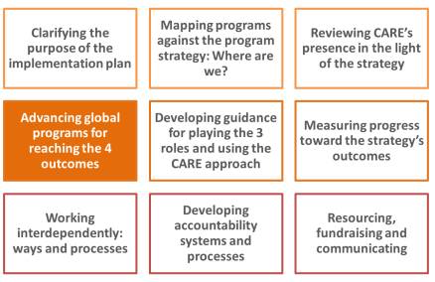
The program strategy includes an ambitious overall outcome: by 2020, CARE and our partners will support 150 million people from the most vulnerable and excluded communities to overcome poverty and social injustice. The strategy also has specific outcomes for our work on humanitarian response, SRMH and the right to a life free of violence, women’s economic empowerment, and food and nutrition security and resilience to climate change. In each of these areas, CARE has considerable experience from decades of solid poverty-fighting programs and from our emergency response.
However, despite the wealth of experience (for example, in FY14 CARE worked on SRMH in 46 countries and reached 37 million people through long-term development projects), often we don’t go the ‘extra mile’ which is required for using the learning from programs for multiplying impact beyond the boundaries of our most immediate work. For achieving our aspirational outcomes, we need to strengthen CARE’s connectedness (within the organization and with others), knowledge management and learning, our ability to play the ‘multiplying impact’ role, particularly advocacy, and using the ‘CARE approach´ in all programs. We have great and often undervalued/underused assets at CARE (e.g. community scorecard, VSLA, successful work in preventing GBV, etc.) that – if used well – are a great source for multiplying impact. We need to better own and communicate our experiences.
In determining how to work toward the strategy’s outcomes, the role of country and regional-level programs is central. Therefore, it is important to build on existing programs and evidence. Colleagues leading outcome areas need to learn and share learning from CARE’s country and regional-level programs for leveraging knowledge for greater impact. Also, a focus on increasing learning across the Global South is critical.
Actions we must take right-away
- Develop coordination structures for advancing toward outcomes. What institutional architecture is conducive to making the desired progress? POC, Program Team with inputs from several teams
- Ensure all CARE entities are briefed on status and structure of outcome areas and are encouraged to engage and align. Secretary General, Program Team and Program Directors
- Develop one-page briefs for each of the outcome areas (flagship programs, main strategies and partnerships, milestones, funding plans and budget). Teams leading outcome areas
- Review/develop humanitarian, SRMH/GBV, women’s economic empowerment, food and nutrition security/resilience to climate change strategies in the light of the program strategy. Be clear about CARE’s added value and ensure strategies include roles and approaches. Teams leading and contributing to outcome areas
- As part of developing/updating strategies for the outcomes, carry out power analyses to identify change goals, thus enabling purposeful ‘multiplying impact’ and advocacy processes. Teams leading outcome areas and AMC, with inputs from many teams across CARE
- Clearly communicate plans for impact reports for the next four years and plan for using evidence from these reports for influencing policies. Program Team and AMC
- For all outcomes, be clear about steps for deepening the connection between humanitarian and long-term development programs. ERWG, CEG, POC, Program Team and teams across CARE
- Learn from CEG, CIGN and PECCN models about CARE’s interdependent ways of working for advancing our work on the 4 outcomes. POC, CEG, CIGN, PECCN and Program Team

Actions requiring further thought/fleshing out
- Establish/deepen key partnerships for advancing the outcomes. Teams leading and contributing to outcomes, CIGN, Program Directors
- Develop solid KM&L systems and processes for outcome areas. KMWG and PIIRS
- Build incentives for links between outcome areas. It is important to retain the thinking of the strategy as an entirety. Program Team to facilitate

Developing guidance for playing the 3 roles and using the CARE approach

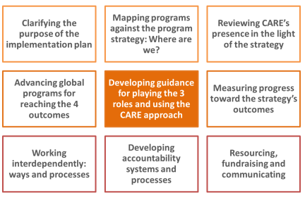
The strategy identifies three main roles that CARE plays for impacting on poverty and social injustice (humanitarian action, promoting lasting change and innovative solutions and multiplying impact) as well as three approaches that are critical for addressing the underlying causes of poverty (strengthening gender equality and women’s voice, promoting inclusive governance and increasing resilience). Using these roles and approaches defines our identity as CARE and the implications of applying these roles and approaches are truly transformational.
Significant progress has been made at CARE in integrating the roles and approaches in the past decade, especially through the rights based approach, unifying framework, underlying causes of poverty analysis and program approach. This has been a profound and important change for CARE. Through the program strategy, we have the opportunity to focus on some critical change areas, in particular in regard to the approaches, which call for a focus on rights for addressing the structural causes of poverty. The aspiration of ‘the CARE approach’ is transformative action that responds to local realities and addresses structural causes of poverty and injustice.
Actions we must take right-away
- Elaborate more clearly each role and approach, as well as the overlaps and distinctions between them, and their links to outcomes areas. Several teams, including AMC, CEG, CI gender network, FNS team and PECCN
- Use the roll out of the program strategy to clarify current status of existing frameworks, such as the program approach, program principles, rights-based approaches and project standards. Propose a review to ensure consistency across these frameworks in light of the strategy. Program Team and regional program teams
- Invest in supporting the adoption of approaches and playing the priority roles. All program teams

Actions requiring further thought/fleshing out
- Develop guidance for playing the roles and using the CARE approach, including case studies, standards, integrating approaches, etc. Program Team, CEG, AMC, PECCN, CI gender network, governance team, program teams
- Develop guidance on partnerships and on engaging with civil society. European Program Directors lead the process with inputs across CARE

Measuring progress toward the strategy’s outcomes

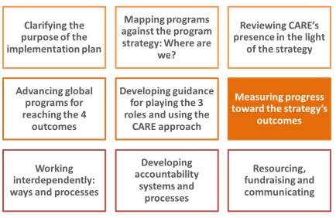
Regular program evaluations, impact evaluations, annual impact reports, as well as the yearly PIIRS survey, are the main tools CARE will use for measuring progress towards the strategy’s outcomes. At the same time, these processes and tools are critical for advancing knowledge management and learning at CARE; the reason why a close collaboration with KM&L teams is essential.
Actions we must take right-away
- Work on the FY15 impact report on the impact of SRMH programs. Analyze impacts in light of the program strategy. PIIRS and SRMH teams
- Use yearly PIIRS data to assess and publish progress toward the strategy’s outcomes. Make this information available online to all CARE staff. PIIRS and Program Team

Actions requiring further thought/fleshing out
- Develop and share across CARE impact measurement guidance and indicators. Disseminate widely and provide training. PIIRS team, Program Directors, CIGN and research partners
- Carry out yearly impact reports in line with the strategy’s outcomes. PIIRS team
- Develop a multi-year research agenda to secure results from impact evaluations of high standards in time for annual thematic global impact reports. PIIRS team
- Develop a knowledge management and learning system, providing access to K&L about successful, evidence-based innovations, increasing our ability to multiply impact. KMWG and PIIRS
Working interdependently: ways and processes
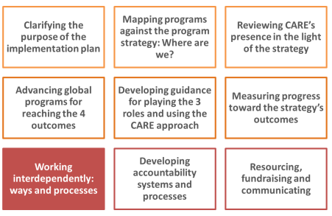
One of the main roles of the Program Team is to foster and facilitate interdependent work across programs and teams. Achieving the outcomes and ambitions set out in our strategy will only be possible by working closely together and establishing solid internal and external partnerships. The Program Team will facilitate reflection and learning, bringing together the roles, approaches and outcome areas. It is critical to build incentives for close collaboration and connection with others, inside and outside of CARE. This collaborative work is also key within each outcome area, without which progress will be slow.

Actions we must take right-away
- Map and connect with teams across CARE that are developing innovations for implementing the program strategy. Invite, share, connect and engage. Program teams across CARE
- Establish a mechanism for sharing key initiatives, to help link those who have common interests, to improve alignment and interdependence, and reduce overlap and duplication. Program Team and Program Directors
- Look at ‘dotted lines and matrix–approach’ across teams and positions for furthering interdependent work. Program Directors and teams

Actions requiring further thought/fleshing out
- Ensure all program job descriptions have a percentage assigned to implementing the program strategy and our common agenda. Program Directors

Developing accountability systems and processes

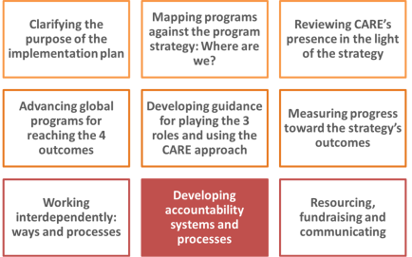
As stated in the strategy document, the program strategy guides the decisions and investments of all parts of CARE. All programming must be consistent with the roles and approaches outlined in this strategy. Acknowledging that building alignment will require time, it is key to ensure that decisions by CARE members on resource investments and fundraising build this alignment. Systems will be developed and implemented to monitor accountability for the implementation of and alignment with this strategy. It is also central to develop accountability systems and processes for being held accountable by external stakeholders, such as partners, members of impact groups and donors.

Actions we must take right-away
- Map existing capacity of CI Members and programs against the strategy. Ask CI Members to state their commitments/support for advancing the strategy and report at Board meetings the progress against these commitments. CI Members, Secretary General and Deputy Secretary General
- Develop guidance for revising CI Member and Country Office strategic plans in the light of the strategy. Align planning processes (i.e. AOPs, APAAs, etc.) for ensuring progress toward the strategy. POC and Program Team
- Identify and strengthen processes that are conducive to accountability vis-à-vis the program strategy. What processes do we have in place and how do we need to strengthen them to be held accountable by partners, donors and communities? Program Team and Program Directors to map
- Move from awareness and familiarity to commitment. We are more accountable if we believe passionately in something! Engage true commitment, and promote an attitudinal change. Celebrate and reward! All teams
- Build indicators of alignment into log-frames, budgets, programs, APAs, annual objectives, etc. Use budgets as a means of being accountable and ‘publish’ intra-organizationally budget decisions. Program Team and Program Directors
- Look at JDs and existing planning processes for reinforcing alignment. HR working group
- Include updates about the program strategy progress as a ‘standing item’ in strategic meetings (CI Board, National Boards, SMT meetings, etc.). All teams

Actions requiring further thought/fleshing out
- Carry out peer reviews and promote collective reflection. Consider developing ‘buddy system’ for supporting alignment. All program teams
- Partner with major research institution for assessing whether the approaches we are using are making a difference. All program teams
- Avoid ‘minimum standards’ culture and describe what true success looks like. Use ‘race to the top’ mechanisms as a way to advance. All program teams
- Track innovations and hold all accountable for scale up. All program teams
- Agree on how to call out ‘non-alignment’ and ‘non-decisions’. Executive Committee and POC
- Consider establishing a global learning week on progress toward the program strategy prior to CI Board meetings. Program Team

Resourcing, fundraising and communicating

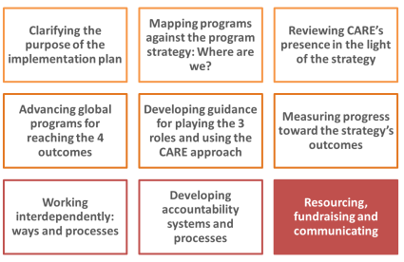
Resourcing, fundraising and communicating are critical for advancing toward the strategy’s outcomes and aspiration. For CARE to succeed, it is key to go beyond ‘alignment’ and bring these areas into all initial and ongoing planning. It is critical to focus our restricted funding on the program strategy and grow our flexible, unrestricted income through increasing our base of individual, regular supporters. Launching fundraising in markets from the Global South is another important strategy for growing resources in support of the strategy. Finally, we will need a more proactive donor engagement strategy across CARE as part of our multiplying impact and funding growth agendas.

While this is an area that requires more ‘fleshing out’, included here are some initial thoughts for driving alignment. It will be key to work with all CI Members for adequate resourcing, as well as with the F&B Committee and the Communications Working Group (COMWG) for successful fundraising and communications.

Actions we must take right-away
- Communicate clearly what we are about, especially externally, so that we can be held accountable by others who know of our program strategy. Use the 70th anniversary of CARE’s founding as an opportunity for communicating about the strategy. COMWG
- Include in communication opportunities (at all levels) what alignment means and how to accomplish it. Send consistent and inspirational messages about implementing the program strategy. Keep the belief and inspiration. All teams
- CI Members specifically include the program strategy as a key element of annual reports and messaging to donors and supporters. National Directors
- Incorporate funding and cost recovery planning into the processes for global programs. F&B Committee

Actions requiring further thought/fleshing out
- Secure new revenue within the program strategy rubric through targeted and innovative fundraising. F&B Committee
- Assess investment options for new fundraising options in Global South countries. F&B Committee
- Develop advocacy campaigns for program impact, public mobilization, engagement and support. AMC, COMWG, F&B Committee, Program Team

- Opportunities and obstacles for advancing the Program Strategy

Beyond the concrete actions around the elements of the implementation plan (described above), it is important to reflect about our main opportunities for advancing the CARE 2020 Program Strategy. It is also critical to identify the obstacles that could prevent us from making progress. We would like to share some reflections about what may be some of the main opportunities and obstacles and invite all to add to these lists. Most importantly, and once identified, it is central to act – both for using opportunities as well as for overcoming obstacles.

Opportunities for advancing the CARE 2020 Program Strategy

- Identity, relevance and motivation. There is a broad realization that change is indispensable for impact and relevance. The strategy presents a common program vision for CARE. It shapes our identity and allows us to rally behind a clear purpose. It is key to use the program strategy as a ‘galvanizing moment’ for CARE and there is appetite for showing how each part of the organization can contribute to its success.
- Deep change in programs in past years. There has been a profound program change in the past years at CARE. Teams are reflecting about how power plays out, innovating, and using scale up strategies. This is a solid grounding for the vision presented in the program strategy.
- Focus on gender. We have a CI gender policy and gender is at the center of many or our meetings. We have solid experience in promoting gender equality and strengthening women’s voice.
- Experience in playing roles. We have solid and successful examples of playing the roles well (e.g. how to use advocacy for influencing national policies and multiplying impact beyond a project). Let’s identify, document, celebrate and build on these successes!
- Climate change strategy. We have a CARE International climate change strategy and CARE views the causes and consequences of climate change as one of the biggest injustices in the world. We have solid experience in promoting climate justice and resilience and adaptation to climate change impacts.
- Knowledge management, learning and impact measurement. Some areas have made important progress in knowledge management and learning (e.g. climate change website). We can learn from these successful experiences. PIIRS has made significant progress for measuring our reach in alignment with the program strategy and for setting a process in place for yearly impact reports.
- Interdependent work at CARE. Real collaboration is already happening at several levels. Several processes for interdependent work are in place and can lead by example (e.g. CEG).
- Partnership. Other organizations have similar challenges as we do for developing genuine partnerships. We can work with them in a more connected and innovative way for working toward deeper partnerships. We also need to consider new business models by partnering with others, and encourage non-traditional way of partnerships to create impact at scale, as we become leaner and more efficient in our operations through new processes, operating model and products.
- Majority of staff working in the Global South. There are inspired colleagues at CARE that are champions within their sphere of influence for furthering the strategy. The vast majority of CARE’s staff is based in the countries in which we seek impact.
- CARE’s governance and membership. The Delhi Resolution provides an opportunity for true transformation of decision-making at CARE, which needs to be more rooted in the perspectives of the Global South. This is critical for the success of the strategy.
- Fundraising. Having a program vision allows for more successful fundraising. To date it has been difficult to ‘sell CARE’ given our multiple priorities. The strategy’s concepts can be easily marketed.
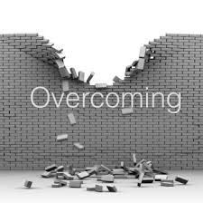
Obstacles we need to overcome – potential ‘killer issues’

- Isolationism and fragmentation or ‘aligning within one’s own bubble’. The strategy will only be successful if we connect and are truly global. To date, we have been a fragmented organization and it is critical to build bridges between the different parts of CARE. We need to recognize mutual obligations to each other within the CARE International Confederation.
- Mind-set. ‘Global North transfers resources to Global South’ mind-set is still embedded in many of our processes. This is often hard to identify/realize because it is so entrenched in the way we operate, in our communications and fundraising.
- Stretched staff due to complex systems, processes and insufficient investment in programs can risk the success of the strategy. In particular, staff working in countries where we seek impact is burdened with many processes.
- Skills. We have limited skills for some of the areas of the program strategy, such as multiplying impact. Our mind-sets, capacities and business models are not conducive for innovation. We want to do different things in a different way, but don’t put effort in making this happen. How will we become advocates and conveners?
- Partnerships and perspectives from the Global South. There has been slow progress in engaging perspectives from the Global South and developing genuine partnerships. There is a ‘disconnect’ between how we would like to work in partnership and how we are structured from a compliance perspective. How will the program strategy help change our approach to partnership? How do we get out of the sub-contracting attitude?
- Use of information and KML. We lack ability to weigh information in an increasingly complex world and act in a timely manner. We have a fragmented way of capturing learning and when learning occurs, it is often not shared. We also need to significantly improve impact measurement.
- Accountability. We don’t have robust mechanisms for holding ourselves accountable. For aligning to the strategy, such systems are critical!
- Where we invest. Program quality is often the ‘first to go’ when we cut costs.
- Unrestricted resources are critical for implementing the program strategy. This is something which CARE has struggled with for long – innovative and creative fundraising is urgently needed!
Conclusion

Several changes are required in order to successfully implement the CARE 2020 Program Strategy and to prioritize internal investment and reform. This implementation plan proposes concrete actions to deepen the impact of CARE’s programs over time. By working together through programs which are more focused and outcome-oriented, and drawing more effectively on our comparative strengths and knowledge, CARE will achieve greater relevance and impact. The implementation plan seeks to harness the expertise of CARE’s staff worldwide, providing focus and a path forward.

Summary of priority actions for FY15 and the first semester of FY16

Clarifying the purpose of the implementation plan
- Share this document with your team and solicit inputs and ideas for advancing the program strategy. What else can we do for working interdependently toward the strategy’s outcomes, approaches and roles? What other elements should we consider for the strategy’s implementation plan? All teams
- Review the plan and decide what your team’s main contribution for the strategy’s success will be. Which are the innovations, programs and processes that can contribute to advancing the strategy? All teams
Mapping programs against the Program Strategy – where are we?
- Participate in April/May 2015 calls for using the PIIRS online system and provide comments on how to improve PIIRS to fully capture key data. Program Directors and teams
- Develop checklist for program designs for assessing alignment with the strategy. Program Team
- Discuss PIIRS findings (and any other assessments carried out) with teams and agree on actions for strengthening alignment and progress toward program strategy outcomes, approaches and roles. Country Directors, Program Directors and teams
- Lead/facilitate dialogues about opportunities, as well as organizational obstacles, for aligning to the strategy. Where is your team? Agree on measures for strengthening alignment and contribution to strategy. National Directors, Country Directors and Program Directors
Reviewing CARE’s presence in the light of the CARE 2020 Program Strategy
- Assess (without ‘redoing’) presence reviews carried out to date in the absence of the program strategy. What simple adjustments (if any) could be done for better aligning the proposed way forward with the strategy? Country and sub-regional teams who have completed presence reviews
- Revise guidance for presence reviews in the light of the program strategy and the Delhi Resolution. Program and Operations Committee (POC)
- Include at least one colleague from another country representing the Global South in steering committee of presence review. Teams leading upcoming reviews
Advancing programs for reaching the 4 outcomes
- Develop coordination structures for advancing toward outcomes. What institutional architecture is conducive to making the desired progress? POC, Program Team with inputs from several teams
- Ensure all CARE entities are briefed on status and structure of outcome areas and are encouraged to engage and align. Secretary General, Program Team and Program Directors
- Develop one-page briefs for each of the outcome areas (flagship programs, main strategies and partnerships, milestones, funding plans and budget). Teams leading outcome areas
- Review/develop humanitarian, SRMH/GBV, women’s economic empowerment, food and nutrition security/resilience to climate change strategies in the light of the program strategy. Be clear about CARE’s added value and ensure strategies include roles and approaches. Teams leading and contributing to outcome areas
- As part of developing/updating strategies for the outcomes, carry out power analyses to identify change goals, thus enabling purposeful ‘multiplying impact’ and advocacy processes. Teams leading outcome areas and AMC, with inputs from many teams across CARE
- Clearly communicate plans for impact reports for the next four years and plan for using evidence from these reports for influencing policies. Program Team and AMC
- For all outcomes, be clear about steps for deepening the connection between humanitarian and long-term development programs. ERWG, CEG, POC, Program Team and teams across CARE
- Learn from CEG, CIGN and PECCN models about CARE’s interdependent ways of working for advancing our work on the 4 outcomes. POC, CEG, CIGN, PECCN and Program Team

Developing guidance for playing the 3 roles and using the CARE approach
- Elaborate more clearly each role and approach, as well as the overlaps and distinctions between them, and their links to outcomes areas. Several teams, including AMC, CEG, CI gender network, FNS team and PECCN
- Use the roll out of the program strategy to clarify current status of existing frameworks, such as the program approach, program principles, rights-based approaches and project standards. Propose a review to ensure consistency across these frameworks in light of the strategy. Program Team and regional program teams
- Invest in supporting the adoption of approaches and playing the priority roles. All program teams
Measuring progress toward the strategy’s outcomes
- Work on the FY15 impact report on the impact of SRMH programs. Analyze impacts in light of the program strategy. Commence work on the FY16 impact report on CARE’s humanitarian work. PIIR, SRMH and humanitarian teams
- Use yearly PIIRS data to assess and publish progress toward the strategy’s outcomes. Make this information available online to all CARE staff. PIIRS and Program Team
Working interdependently: ways and processes
- Map and connect with teams across CARE that are developing innovations for implementing the program strategy. Invite, share, connect and engage. Program teams
- Establish a mechanism for sharing key initiatives, to help link those who have common interests, to improve alignment and interdependence, and reduce overlap and duplication. Program Team and Program Directors
- Look at ‘dotted lines and matrix–approach’ across teams and positions for furthering interdependent work. Program Directors and teams
Developing accountability systems and processes
- Map existing capacity of CI Members and programs against the strategy. Ask CI Members to state their commitments/support for advancing the strategy and report at Board meetings the progress against these commitments. CI Members, Secretary General and Deputy Secretary General
- Develop guidance for revising CI Member and Country Office strategic plans in the light of the strategy. Align planning processes (i.e. AOPs, APAAs, etc.) for ensuring progress toward the strategy. POC and Program Team
- Identify and strengthen processes that are conducive to accountability vis-à-vis the program strategy. What processes do we have in place and how do we need to strengthen them to be held accountable by partners, donors and communities? Program Team and Program Directors to map
- Move from awareness and familiarity to commitment. We are more accountable if we believe passionately in something! Engage true commitment, and promote an attitudinal change. Celebrate and reward! All teams
- Build indicators of alignment into log-frames, budgets, programs, APAs, annual objectives, etc. Use budgets as a means of being accountable and ‘publish’ intra-organizationally budget decisions. Program Team and Program Directors
- Look at JDs and existing planning processes for reinforcing alignment. HR working group
- Include updates about the program strategy progress as a ‘standing item’ in strategic meetings (CI Board, National Boards, SMT meetings, etc.). All teams
Resourcing, fundraising and communicating
- Communicate clearly what we are about, especially externally, so that we can be held accountable by others who know of our program strategy. Use the 70th anniversary of CARE’s founding as an opportunity for communicating about the strategy. COMWG
- Include in communication opportunities (at all levels) what alignment means and how to accomplish it. Send consistent and inspirational messages about implementing the program strategy. Keep the belief and inspiration. All teams
- CI Members specifically include the program strategy as a key element of annual reports and messaging to donors and supporters. National Directors
- Incorporate funding and cost recovery planning into the processes for global programs. F&B Committee

‘Program Directors’ refers to program leaders at all levels – CI Members and Country Offices.
‘Program Directors’ refers to program leaders at all levels – CI Members and Country Offices.

